Final Test 2021

GET1041

A0217200B

Teng Hau Wei



1. ***"A map of the world that does not include Utopia is not worth even glancing at, for it leaves out the one country at which Humanity is always landing. And when Humanity lands there, it looks out, and, seeing a better country, sets sail. Progress is the realisation of Utopias."* —**[**Oscar Wilde**](https://en.wikipedia.org/wiki/Oscar_Wilde)

***“All paradises, all utopias are designed by who is not there, by the people who are not allowed in.*” [Conversation with Elizabeth Farnsworth, *PBS NewsHour*, March 9, 1998]**

***“All utopias are dystopias. The term "dystopia" was coined by fools that believed a "utopia" can be functional.”*― A.E. Samaan**

**Which of these quotes (if any) best sums up what you think is the vision of Utopia represented by Walt Disney and the Disney corporation? How might you assess the role of films, theme parks, and Disney business strategies and practices in terms of furthering a vision of utopia both in the US and internationally? Do you think that Disney has influenced utopian visions in Singapore?**

Of the three quotes, Wilde’s take on the utopia is most optimistic, characterising utopia as realisable prototypes and necessary. On the other hand, both Morrison and Samaan pessimistically characterise utopia as being fictional, unrealisable, and possibly dangerous. The main difference is that Wilde believes in a realisable utopia, while Morrison and Samaan believes utopia to be unrealisable.

I think that Wilde’s take on utopia best sum up Disney’s vision of utopia. However, outsiders’ critic of Disney’s visions of utopia may be better represented by Morrison and Samaan’s take on utopia.

To simplify things, it is helpful to understand Disney as a merchant that profits by trading an underlying commodity of optimism. This commodity of optimism is coordinated and marketed as Disney magic, the unifying motif of all products ranging from films to urban spaces to merchandise.

When Disney applies this motif of optimism into envisioning future society, they are more than critical commentaries on reality but experimental prototypes in attempts of realising utopia – utopias manifests Disney’s optimism on future society.

The town of Celebration is one of the utopic manifestations of Disney’s optimism in the sphere of urbanism.

Being a student of the built environment, one of the new urbanism books introduced to us compared the town of Celebration and the town of Kissimmee, a nearby town in Florida. It highlighted how new urbanist planning made Celebration a more successful urban space than Kissimmee. (Marshall, 2000) Celebration has become a model for new urbanism success.

Disney’s experimentation with utopia (as it optimistically envisions it) translates into prototypal realisations. They become models of progress.

The optimistic experimentation of utopia is also reflected in films. For instance, the 2021 Disney film “Raya and the Last Dragon” is a commentary of utopia and dystopia.

The tribes in the land of Kumandra was thematically named after the five body parts of a dragon: Fang, Heart, Spine, Talon and Tail. At the beginning of the film, the protagonist Raya narrates and describes the land that was ravaged by strife and disharmony between the tribes as a “dystopia”. The film ends happily when the protagonists manage to unite the five tribes harmoniously and utopic scenes were portrayed where the various tribespeople came together celebratedly in one place with a harmonious happy ending.

Disney’s visions of utopia are celebrative, optimistic and progressivist. Disney’s utopia is presented as realisable through Disney optimism. These visions of utopia found in films and stories are furthered globally as part of the Disneyization process that distributes the Disney curriculum.

As I watched the film, there inspired a vision of reality: I imagined that South East Asia (currently divided into nations) were to harmoniously united together, South East Asia would be a better place – a utopia of sorts. The ending scene (though Asiatically portrayed) had me think about how it resembled the World’s Fair where the various tribes congregated together in festivities and meals.

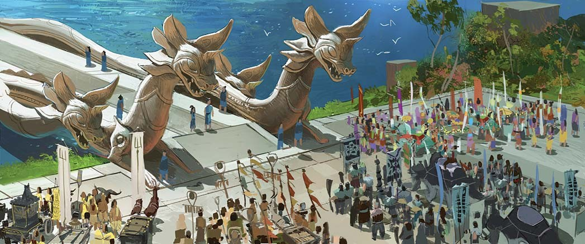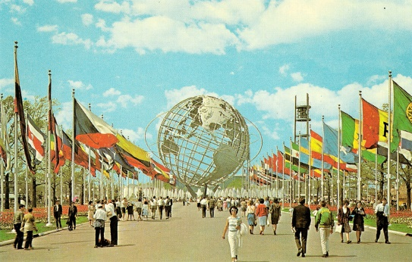

Figure 1: Raya and the Last Dragon ending scene (Left), World’s Fair (Right)

Relevant to the topic of Disney’s furtherance of its visions of utopia I introduce the community mega project of Our Tampines Hub in Singapore.

Having spoken to one of the architects for the place (during a guest lecture), he mentioned that Disneyland was an inspiration for the design paradigm. The building was designed to be fun, festive and ubiquitously mass-market for diverse ages and backgrounds. The planning of the space resembles Disney’s utopia, where people of diverse backgrounds congregate in one celebrative place to live and enjoy. The mega centre is divided into themed spaces such as “Festive Square”, “Public Service Centre”, “Festive Mall” and “Town Square”. There is a coordinated spatial experience where bird chirping sounds were played from speakers and in the centre of the building is a large screen that also happen to play Disney movies often.

It was pioneered as one of Singapore’s experimental public space and it is today considered a success for future Singaporean public projects to learn from. It is noteworthy that Disneyland was cited by the architect as an inspiration for the designing of the building, it is where Disney’s fictional utopia has inspired a real-life functional community utopia.

Linking back to Wilde’s comment, I believe that it is Disney’s optimism towards utopia that allowed Disney to experiment in spaces and narratives prototypes of utopia. These prototypes of utopia, having proven themselves successful, then creeps into other spheres of society to be realised. It is a Disneyization of utopian visions.

Yet I will not dismiss the critical representation of Disney’s visions of utopia. Morrison’s and Samaan’s view that utopias are unrealistic and fictional do represent Disney’s visions of utopia.

Disney stories, EPCOT and Disneyland are mere fictional works and they are rosy portrayals of utopia. They exist as perfect future places and societies simply because of the imagination and theatrical works of planning, writing, animation, and engineering. The perfect paradisical places do not exist, they are fictional.

Beyond urban spaces, the WIRED article from an earlier forum compared the Singaporean society to Disneyland with the death penalty. This criticism of Singapore and Disneyland echoes the sentiments of Samaan – that utopias are functionally dystopias.

It offers insights to the parallel between Singaporean society and Disneyland, highlighting the immense control leading to a loss of freedom in manicuring and curating a false utopia. For every celebration of Singapore as a low-crime paradise, there are human rights criticisms of caning and the death penalty and for every praise of Singapore as a racially harmonious utopia, there are reports of racial microaggressions.

I believe that this contradiction exists because utopia is thought of to be the perfect society while the fact is that perfection is unattainable. Morrison and Samaan understands “utopia” as the perfect society or place which is dismissed as non-existent. Wilde however implies that society, though imperfect, ought to attempt pursuing perfection (though possibly never attaining it) and that is the realisation of “utopia”.

Depending on perspective, the three do represent visions of utopia of Disney and Singapore.

(998 words)

4. **Consider theming as a principle of spatial organization. What influence does theming have on people who visit and work in those spaces? Critically evaluate examples of themed spaces covered in this course and what various authors have said about theming and its effect on work, play and social interaction.**

Theming is the synergistic threading of narratives together into clusters of similar themes. It is one of the most crucial dimensions that drives the process of Disneyization.

Firstly, theme parks are characterised as “cultural mind-maps” by King and O’Boyle. This is a sensible characterisation of theme parks which is coordinated to bring out a narrative through optimising the spatial experience of the visitor. Theming (through the coordination of the spatial experience) pervades into the being of the visitor.

In a scientific tangent to this point, humans instinctively have good visuo-spatial memory for the function of navigation. (Newcombe & Frick, 2010)

The organisation of spaces into themes powerfully leverages onto human natural instinctive ability to mentally process visuo-spatial information to bring forth narratives. As King and O’Boyle puts it, the theme park is still a theme park without the rides. It is the visuo-spatial experience, more than the amusement rides, that engages the visitor. This is as if the static design is curated from the dynamic camera lens of the visitor.

When coordinated multi-dimensionally, the theme park is a narrativized space that powerfully eclipse the significance of its original physical space, as Philips puts it,” a space unapologetically penetrated by influences quite distant from its geographical location, and which distances itself from its actual locale”.

It is the intangible narratives that is put into a tangible physical space that makes it more significant, this is done through theming. The tangible physical space is nothing more than construction and land, but theming makes the space narrativized “alive”.

Themeing therefore can also be understood as the weaving of the physical space and the intangible narratives together for a narrativized human spatial experience.

Theming does not only apply to convert raw space into narrativized space but also labour. Lukas has critically given insight on the theming of labour, which we understand as performative labour.

Just as theming strips the context of the land to input a narrative onto the land, theming strips the individuality of the workers that they can bring forth the narrativized experience.

Lukas described how theming pervades into the individuality of the worker, where the worker takes on the act as part of his identity. In an example, the worker who was supposed to act western to fit in the western theme goes overboard to absorb the cowboy identity that he acted rudely towards a visitor.

As a result of the multi-pronged coordination of labour and space for the narrativized visitor experience, the visitor immerses into the narrative, believing that both the performative labourer and the space are part of the fantasy.

This results in a positive feedback loop where the visitors and the staff (having been socialised to embrace the performative role as part of their identity) hence place an expectation on the performative worker to behave in the certain way. The influence of the visitor on the staff and the staff on one another is described by Van Manen and Hickey.

The discussion above analyses theming in these layers:

1. Theming puts narratives into spaces
2. Theming puts narratives into workers
3. Theming elicits a response from the visitors
4. The visitors and the workers place expectations on other workers to behave according to the narratives
5. Theming thus self-reinforces.

The main example in this module of Disney theme parks give insight to the process of theming as lined out in the framework above.

Disney theme parks are in suburban lands, containing themed lands which are exotic representations of places apart from the original land. This is the imputation of narratives into spaces.

Disney workers are trained and socialised to identify and perform their roles. For instance, workers are trained to have uniform signatures of their characters. They eventually absorb the identity of the character that they are portraying as they engage in this performative labour. This is the imputation of narratives into the workers.

The visitors buy into the theatrical display of the space and the workers. Theming thus elicits a belief from the visitors whose are spatially engaged and immersed into fantasy.

During so they also expect the other workers to behave according to the narrative. They bring their children in expectations of having their children be immersed in the narrative as well.

This deep dive into theming gives much insight to how theming as a dimension of Disneyization makes the process of Disneyization so pervasive.

Another themed space that the module has introduced are royal palaces. They are identified as early instances of themed spaces.

In a historic tangent to this point, using the Palace of Versailles as a case, theming makes the people believe in the narrative which is the royalty’s right to rule.

The Palace was originally a hunting lodge in suburban Versailles, but after reconstruction and successful theming from Louis the XIV, it became the central place of French politics. (Rondot, 2018)

Louis the XIV themed the place after himself, which he reimagined himself as the “Sun King”. Emblems celebrating his reign as the “Sun King” which all things revolve around were incorporated into the design of the palace, this is how theming puts the narrative of his rule into spaces.

In a sense, he and his court are both the performative workers and the visitors. Beyond jesters to entertain, his court were part of parties and lavish balls meant to dazzle. The narrative was themed into the “workers” and “visitors”.

The response elicited was then that the “visitors” bought into the “Sun King” fantasy. They then continued this self-reinforcing theming process that furthered the narrative.

In conclusion, theming is a powerful way to bring forth narratives, it weaves together land, labour and capital to make narrativized spaces. It is widely used in many settings.

(952 words)

# References

Marshall, A. C. (2000). *How Cities Work: Suburbs, Sprawl And The Roads Not Taken.* Austin, TX: University of Texas Press.

Newcombe, N. S., & Frick, A. (2010). Early Education for Spatial Intelligence: Why, What, and How. *Mind, Brain and Education*, 102-111.

Rondot, B. (2018). *Chateau de Versailles: Visitors to Versailles.* Metropolitan Museum of Art, New York. Retrieved from https://en.chateauversailles.fr/sites/default/files/visitors_to_versailles_dossier_de_mecenat.pdf